1-4 Assignment: Users and Solutions

CS 360 Mobile Architect and Programming

Nicholle Caudy

5/7/2025

**Purpose**

There are a couple of apps that I use every day, the one that I have selected for this assignment is the Carb Manager app. This application is designed to assist users in monitoring their intake of calories, carbohydrates, protein, and fat with each meal throughout the day. Furthermore, it provides numerous additional features to support users in achieving their weight loss goals. The application's design clearly outlines its purpose. Upon downloading, users are required to input specific information, which enables the application to assist in managing daily carbohydrate intake for achieving weight loss objectives. The app calculates the calories and carbs for each meal based on the entered information. This app offers features for tracking exercise, linking fitness trackers, and recording water consumption. You can also see how close you are to reaching the goal the app has set for your diet for the day with a pie chart.

**User Needs**

The app is used by users who are hoping to lose weight by adjusting their diet and tracking the amount of carbs and calories they are consuming throughout the day. The Carb Manager app calculates the user’s dietary intake and has set the proper amount of carbs and calories per meal to give the user a goal to stay under to achieve their weight loss goals. The app does offer a premium package that offers more support and features with different payment options once a month, once every 3 months, or once a year. The business objective for this app is to offer limited access to all the app features and gain income for full access to every feature available on the app.

**Features**

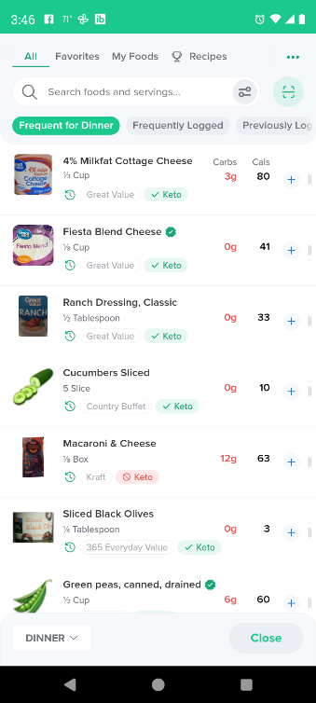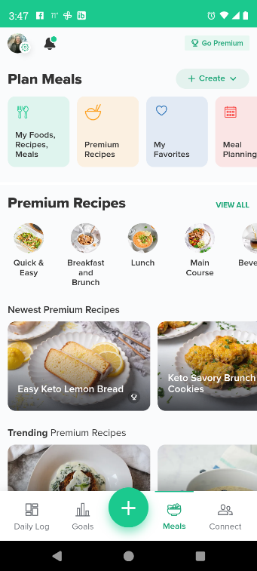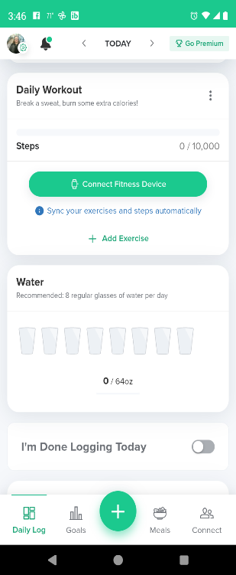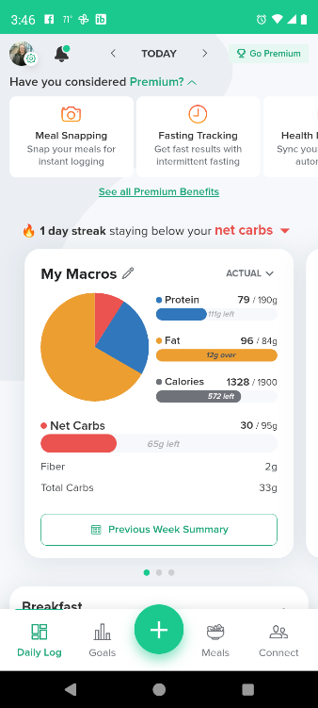

The Carb Manager app offers features to help the user search for the foods they are eating to add them to their meal. There is an option to type in the description or name and a scan option to scan the barcode on the products. There are features to create meals for quick meal entry for people like me who eat the same things frequently, create custom food entry, create a recipe, and import a saved recipe. The app offers a fasting tracker and exercise entry features. The app is amazingly easy to use with clear buttons to press to add food information, add portion sizes, add exercises, enter water consumption, take notes, track weight loss with weight entries, and look at healthy recipes. The screen layout is intuitive, with visible, color-coded daily goals. Meal entries are categorized by breakfast, lunch, dinner, and snack. My favorite feature is the ability to scan barcodes to search for specific foods and their nutrients auto populate for portions to select from. This makes adding food very convenient and takes out the guess work. The tabs present for different screens are very well labeled and self-explanatory.

**User Information**

The user information that would be helpful for this app is understanding how difficult calculating intake can be for a busy individual. I would ask potential users what options they would like to see to ensure the app was helpful for their weight loss journey and they would want to use it long term. How likely are you to continue using the app if you can add intake and exercise? What was lacking from apps you have previously used for intake tracking? What health problems (diabetes) do you face that may affect your weight loss goals? How can this app help manage this health problem? Adding recipes that are healthy and within daily limits can add to the usability and continuation of use. The information asked for after downloading is an essential part of this application, it allows the user to enter their weight, activity level, and weight loss goals. The app offers distinct options for weight loss goals and timelines, ensuring safety. Taking the guess work out for the user and giving them a goal to focus on. Personally, goals work for me, being able to track everything in one place, easy entry, weight loss options, and accessibility are crucial. I have previously utilized applications such as Carb Manager, which proved to be challenging to navigate. Additionally, their calorie and carbohydrate calculations per serving were often inaccurate, and some foods were absent from their database.